Project Proposal

🏪 Store Management System

Objective
The main objective of this project is to develop a simple, user-friendly, and efficient system for managing the daily activities of a store. In many small and medium-sized shops, product records are still maintained manually using notebooks or paper-based systems. This traditional method often leads to mistakes, data loss, confusion, and unnecessary time consumption.

To overcome these problems, this system aims to provide a digital solution that makes store management easier, faster, and more accurate. By using this system, users will be able to handle all store-related operations in an organized way without relying on manual processes.

With the help of this system, users can:
- Manage all product information digitally in a structured format
- Keep track of stock-in and stock-out activities efficiently
- Organize products based on different categories for easy access
- Quickly check the available quantity of any product
- Reduce errors caused by manual calculations and record-keeping
- Save valuable time and improve overall productivity and accuracy

Overall, this project is designed to simplify store management tasks and help shop owners maintain better control over their business operations.

⚙️ Functional Requirement
The system will include the following main features:

👤 User Management
- Users can log in to the system securely
- Only authorized users can access the system
- Users can also log out safely

📂 Category Management
- Add new product categories
- Edit existing categories
- Delete unwanted categories
- View all categories in a list

📦 Product Management
- Add new products with details (name, code, category, etc.)
- Update product information when needed
- Delete products from the system
- View all available products

Stock In (Store Product Entry)
- Add products into stock when new items arrive
- Increase product quantity automatically

Stock Out (Spend Product Entry)
- Reduce product quantity when products are sold or used
- Keep record of all outgoing products

Stock Tracking
- Show current available stock for each product
- Help users understand product availability easily
- Avoid overstock or stock shortage issues

Non-Functional Requirements
These are the quality requirements of the system:
- Fast response time for all operations
- Secure login system to protect data
- Simple and user-friendly interface
- Reliable database to ensure data accuracy
- Compatible with PHP and XAMPP environment
- Easy to use for beginners and non-technical users

Use Case Diagram
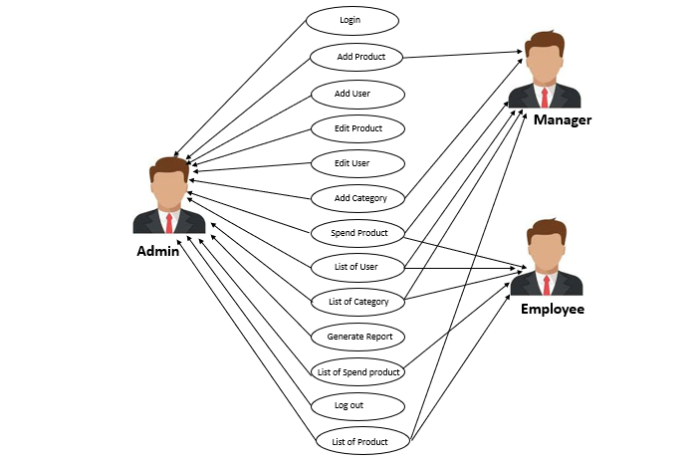

ER Diagram
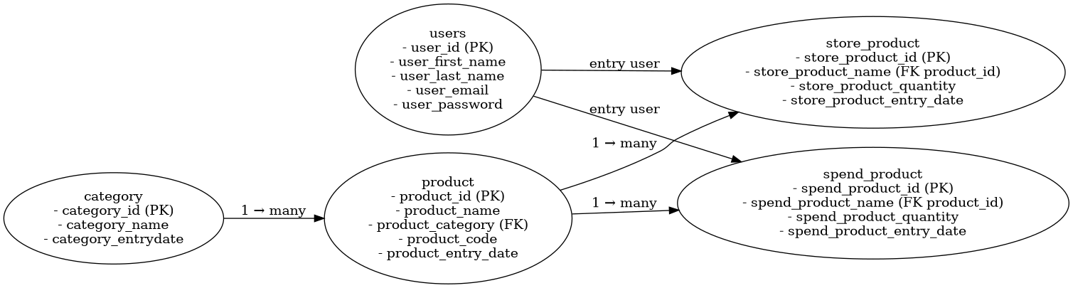

System Description

The Store Management System is a web-based application designed to manage store operations in a digital way.
It helps store owners or employees to:
- Keep records of all products
- Monitor stock in real-time
- Manage categories and product details
- Track sales or product usage
Instead of using paper-based records, this system stores everything in a database, making the process faster, safer, and more organized.

Advantages
- Reduces manual work
- Improves accuracy in stock management

- Saves time in daily store operations
- Easy to access and update data
- Helps in better decision making for stock control

Conclusion
The Store Management System is a simple and practical solution for managing shop activities digitally. It improves efficiency, reduces errors, and makes store management more professional and organized. This system is suitable for small and medium-sized businesses.

